PLEASE MAKE A DONATION NOW
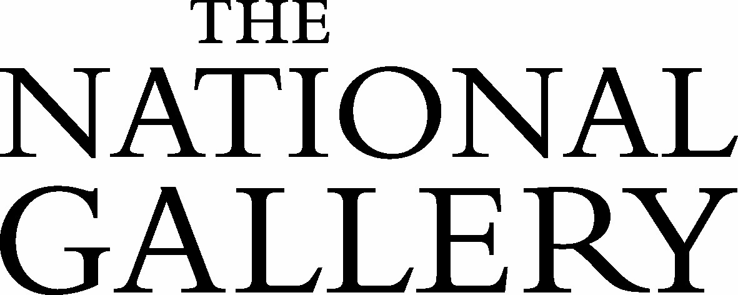

Title: First name: Surname: Home Address:
Postcode: Email: Daytime Phone:
We would like to keep you up to date with information about the Gallery’s latest exhibitions, events, news and more. Please indicate your preferences: I am happy to be contacted by
Email and post Email Post I do not wish to receive future communications from the National Gallery
The National Gallery's privacy policy can be found online at www.nationalgallery.org.uk/privacy-policy

I would like to make a donation of:
£50 £100 £250 Other: £

I would like to make a donation by Credit/Debit Card
Please select: MasterCard Visa Visa Debit/Electron Maestro AMEX Card number

Valid from Valid to CV V Amount
£ Signature Date
I enclose a cheque made payable to ‘The National Gallery’ for £

Gift Aid Declaration:
If you are a UK taxpayer you can boost your donation by 25p of Gift Aid for every £1 you donate. Gift Aid can be reclaimed by us from the tax you pay for the current tax year.
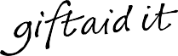

Your address is needed to identify you as a current UK taxpayer.

In order to Gift Aid your donation you must tick one or both of the boxes below: I want to Gift Aid my donation of £ to the National Gallery
I also want to Gift Aid any donations I make in the future or have made in the past 4 years to the National Gallery
I am a UK taxpayer and understand that if I pay less Income Tax and/or Capital Gains Tax than the amount of Gift Aid claimed on all my donations in that tax year it is my responsibility to pay any difference.

Signature: Date:

Please notify us if you: • Want to cancel this declaration • Change your name or home address
- No longer pay sufficient tax on your income and/or capital gains.

If you pay Income Tax at the higher or additional rate and want to receive the additional tax relief due to you, you must include all your Gift Aid donations on your Self Assessment tax return or ask HM Revenue and Customs to adjust your tax code.

Please return this form in an envelope addressed to:
Development Department, The National Gallery, Trafalgar Square, London WC2N 4DN

The National Gallery is an exempt charity in accordance with schedule 3 of the Charities Act 2011 and does not require a registered charity number.

